

COURSE NAME: Algorithm Analysis

STUDENT: Ertuğrul ŞENTÜRK

HOMEWORK SUBJECT: Creating a matrix of n value given according to the rule of "Von Neumann’s Neighborhood"

ALGORITHM:

* The value of n received from the user.
* 2 \* n + 3 size square matrix was initially created with dynamic memory allocation using calloc since all elements should be 0.
* An array of the same size was created to store the number of black squares in each row.
* According to the algorithm, the starting and ending points of the black squares in each row were calculated.
* Since the black squares increase in the upper half and decrease in the lower half, the starting and ending values ​​of the squares were calculated according to the relevant situation.
* Each row is filled in according to the calculated start and end values.
* Since 1 more of the difference between the start and end values ​​will give us the number of black squares in that row, this value has been recorded in the array that holds the number of black squares in the row.
* Matrix and array printed to user.
* The total number of black squares was calculated and printed according to the relevant formula.

PROGRAM OUTPUTS:

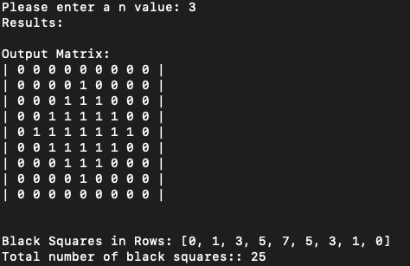metin içeren bir resim

Açıklama otomatik olarak oluşturuldu

for n = 0 for n = 3

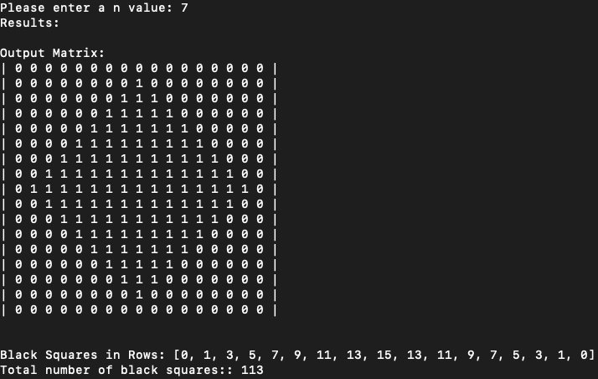

for n = 7